IMPLEMENT A BASIC REINFORCEMENT LEARNING MODEL (Q-LEARNING)

AIM:
To implement Q-Learning and Neural Network algorithms using Python. Q-Learning is used to find the optimal path based on a reward matrix, and the Neural Network is used to predict student results (Pass or Fail) based on hours studied, attendance, and assignments.

ALGORITHM:
1. Import the required libraries such as NumPy, Pandas, TensorFlow, and Scikit-learn.
2. Create a reward matrix and initialize the Q-table with zeros.
3. Set the discount factor to 0.8 and the number of training episodes to 1000.
4. Randomly select an initial state and identify the valid actions.
5. Update the Q-table using the reward and discount factor until the goal state is reached or the step limit is exceeded.
6. Display the final Q-table.
7. Load the student dataset from data.csv.
8. Select Hours_Studied, Attendance, and Assignments as input features.
9. Convert the target labels Fail and Pass into numerical values 0 and 1.
10. Split the dataset into training and testing sets.
11. Scale the input features using StandardScaler.
12. Build a neural network with two hidden layers using ReLU activation and an output layer using sigmoid activation.
13. Compile the model using the Adam optimizer and binary cross-entropy loss.
14. Train the neural network for 50 epochs.
15. Predict the student results using the testing data.
16. Calculate and display the model's accuracy.

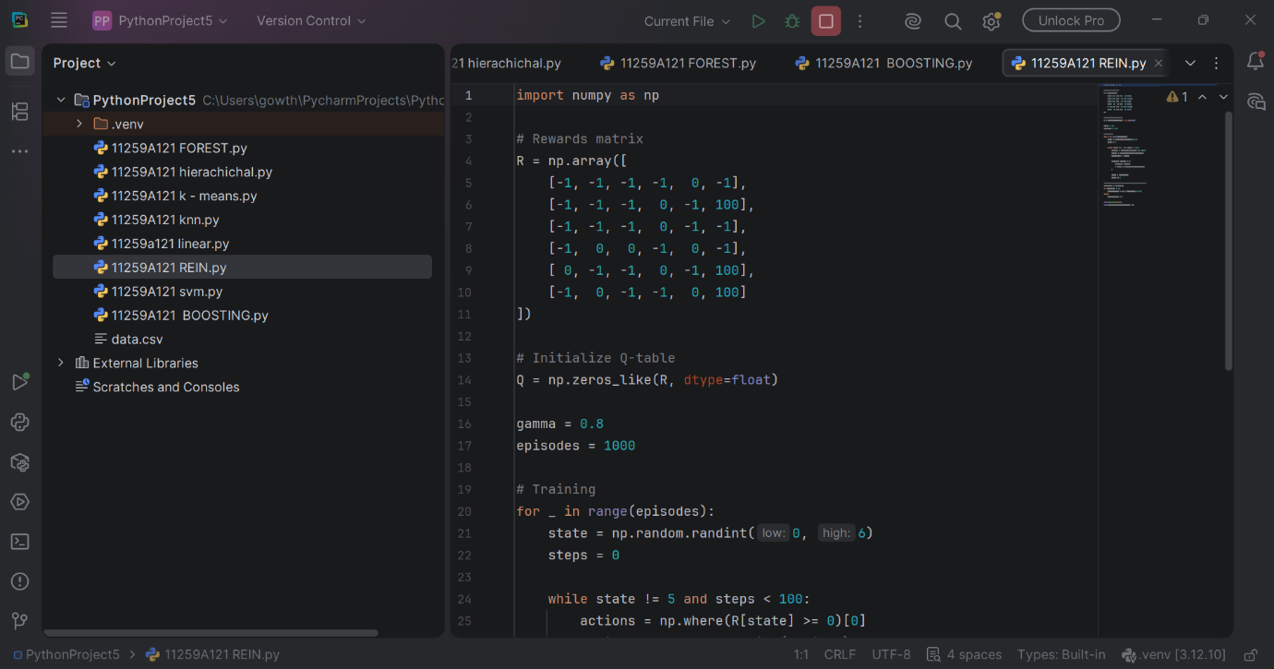

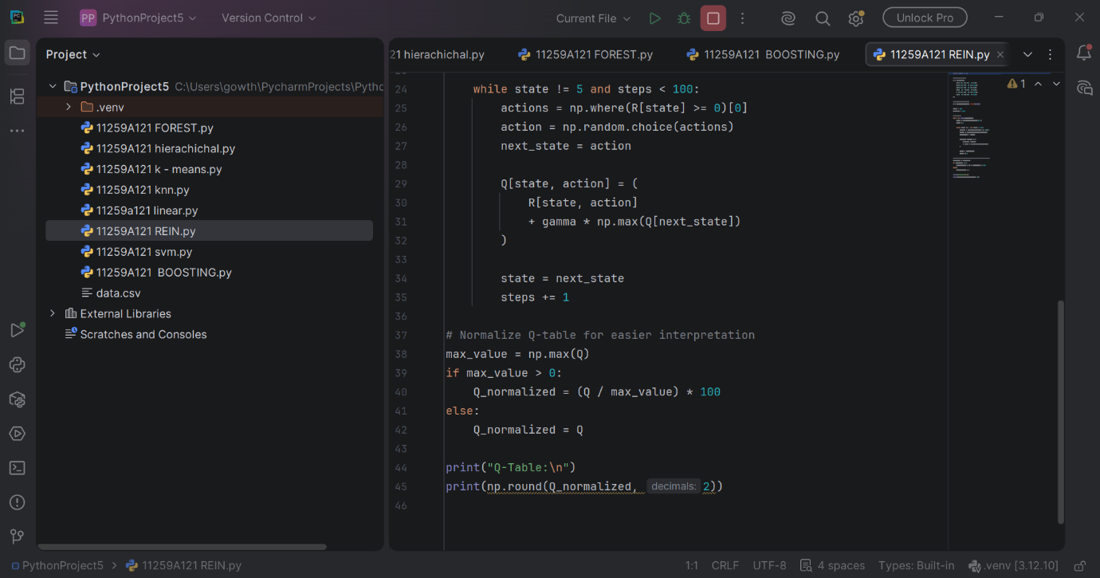
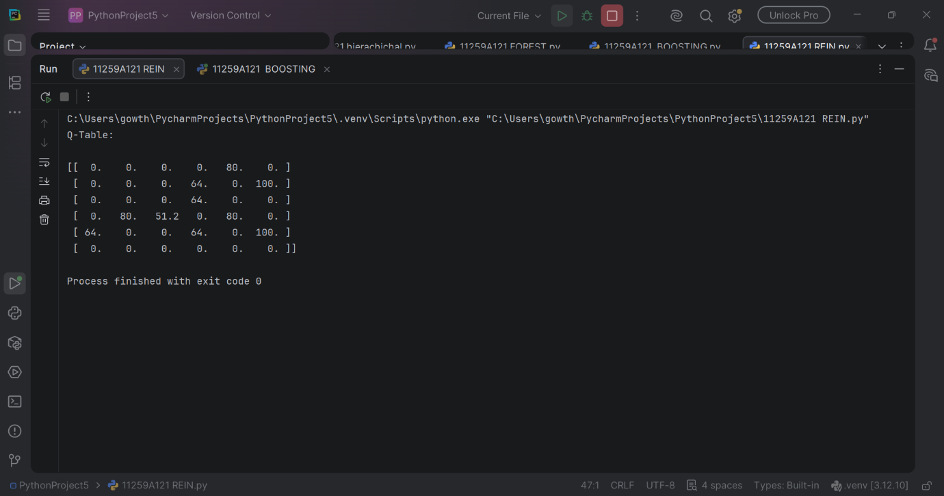

RESULT:
Thus, the Q-Learning algorithm was successfully implemented to generate a Q-table for the given reward matrix. The Neural Network was trained to predict student results as Pass or Fail, and its performance was evaluated by calculating the test accuracy.

